

ATAR Biology

Unit 2: Topic 4

Week 33 Circulation

© SIDE

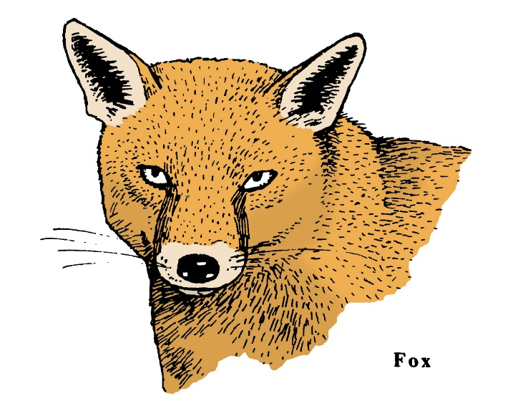

Student Study Notes

Unit Content
- In animals, the transport of materials within the internal environment for exchange with cells is facilitated by the structure of open and closed circulatory systems according to the different metabolic requirements of organisms and differing environments.

The Transport of Materials

The transport system for most animals is a system of tubes containing fluid which circulates around the body as it collects and delivers materials such as oxygen and nutrients.

Circulatory systems in animals are either closed or open. A typical animal circulatory system consists of:

- Blood: mainly red blood cells carrying oxygen suspended in plasma
- Vessels: system of tubes [arteries and veins] which transport blood
- Heart: cardiac muscle which pumps blood through the vessels

Open circulatory system
Most arthropods, such as insects and crustaceans, have an open circulatory system. A long tubular heart pumps blood directly into body tissues. Insect blood carries nutrients. Oxygen is directly supplied to cells through air-filled tubes called trachea.

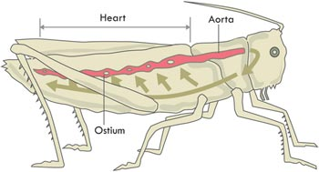
© WestOne

In marine or freshwater crustaceans such as crayfish, the blood flows over gills and collects oxygen by diffusion from the surrounding water.

Closed circulatory system
In a closed circulatory system, the blood remains inside the blood vessels and is not in direct contact with cells.

Materials pass between the blood and the body tissues through thin-walled capillaries by the process of diffusion. These vessels are microscopic with walls one cell thick which allow for rapid diffusion
e.g. earthworms, fish, amphibians, reptiles, birds and mammals.

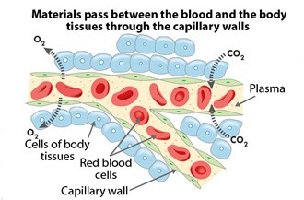
© WestOne

Practice Questions

Explain why cells require a constant supply of oxygen and nutrients.

Do you think the cells of large, complex animals like mammals could be supplied with nutrients in the same way as simpler animals? Explain your answer and describe the way complex animals overcome the problem of supply.

What is the function of the circulatory system in an animal?

Annelids have blood contained within vessels. The blood moves the gases from the body surface to the cells. Explain how this system would differ from that used by a wasp.
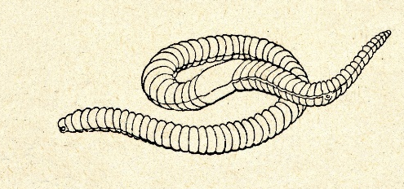

Annelid

5. Describe two differences between the circulatory systems of fish and birds.

6. Distinguish between open and closed circulatory systems. Provide an example of an organism that possesses each type of system.

7. State one advantage of a closed system compared to an open system.

8. Label the diagrams of the mammalian heart.
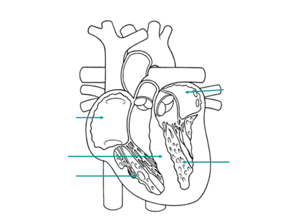

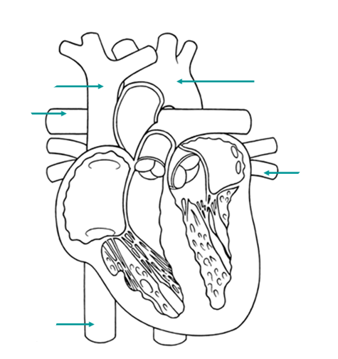

9. Describe the heart of a reptile.

10. In a closed circulatory system,
(a) the blood remains outside the blood vessels and is in direct contact with cells.
(b) the blood remains inside the blood vessels and is not in direct contact with cells.
(c) the blood remains inside the blood vessels and is in direct contact with cells.
(d) the blood flows over gills and collects oxygen by diffusion from the surrounding water.

